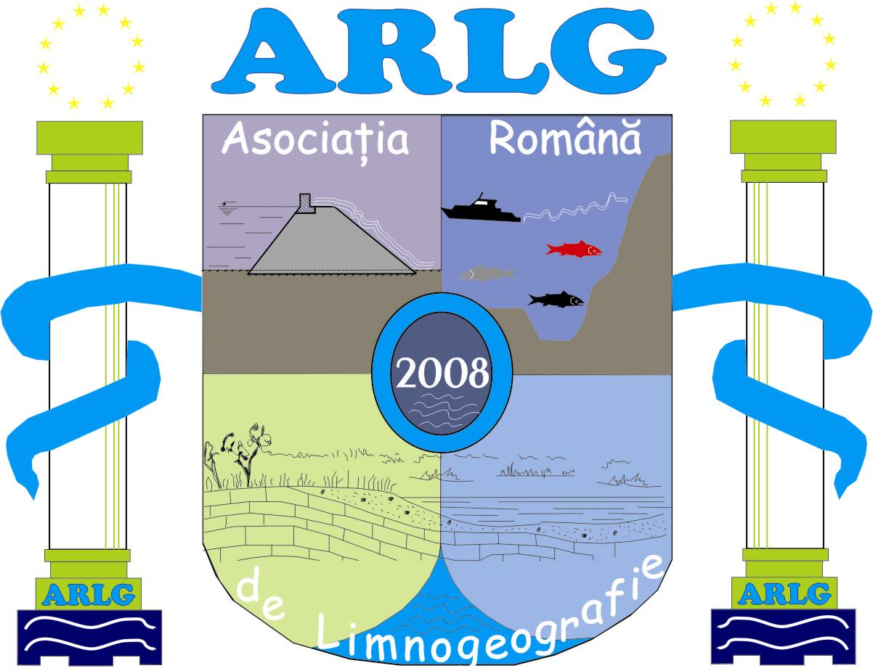



Valahia University of Târgovişte Romanian Limnogeographical Association Institute of Geography Bucharest
www.valahia.ro www.limnology.ro

International Conference
Geography, Environment and GIS
for students and young researchers
Targoviste, Romania, May 22-24, 2014
Official Conference website is:
http://www.limnology.ro/geg2014.html
Please complete this form and return by E-mail latest until April 18, 2014.

• e-mail: geg2014@limnology.ro

Inregistrare
Delegate | Student | Masterand | Doctorand | Dr. & Cercetator (<35 y)
Nume
Prenume
Universitatea / Institutul
Adresa
Orasul
Cod postal
Tara
Tel.
Fax
E-mail

Tipul prezentarii:
Oral | Poster

Sectiunea
A. Geography
B. Environment
C. GIS

Abstract submission (Abstract is a part of registration form)
Titlu (romana)
Titlu (engleza)
Autori
University/Company/Institution
E-mail contact
Abstract (max. 800 words) (romana)
Abstract (engleza)
Keywords (max. 6)
Profesor coord. (doar pentru studenti si masteranzi) (nume, email)

Aplicatie: Yes  No 

